Charts and Business Data
Synthetic bar chart:
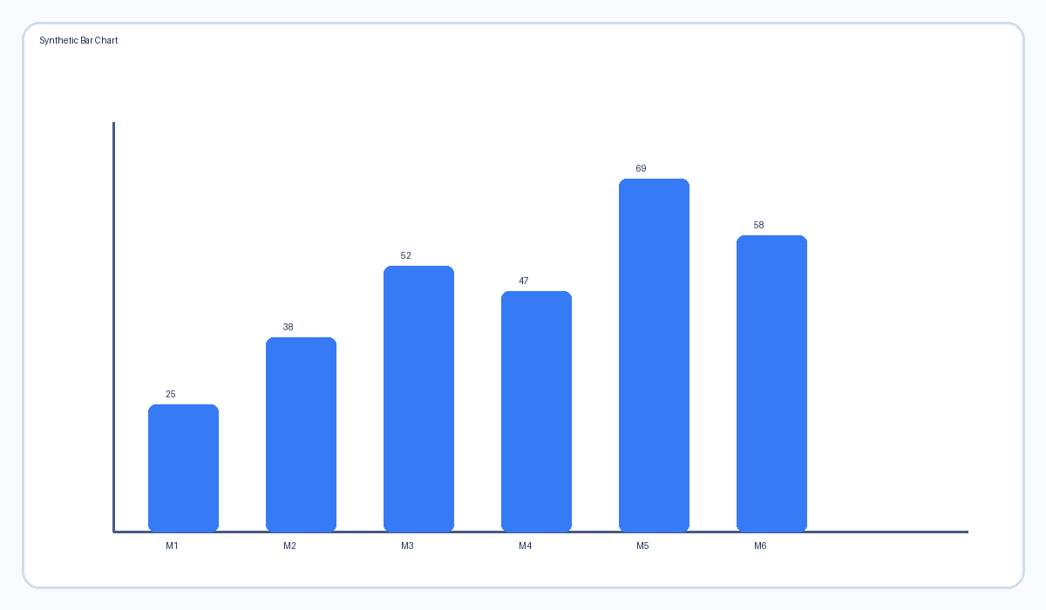
Synthetic line chart:
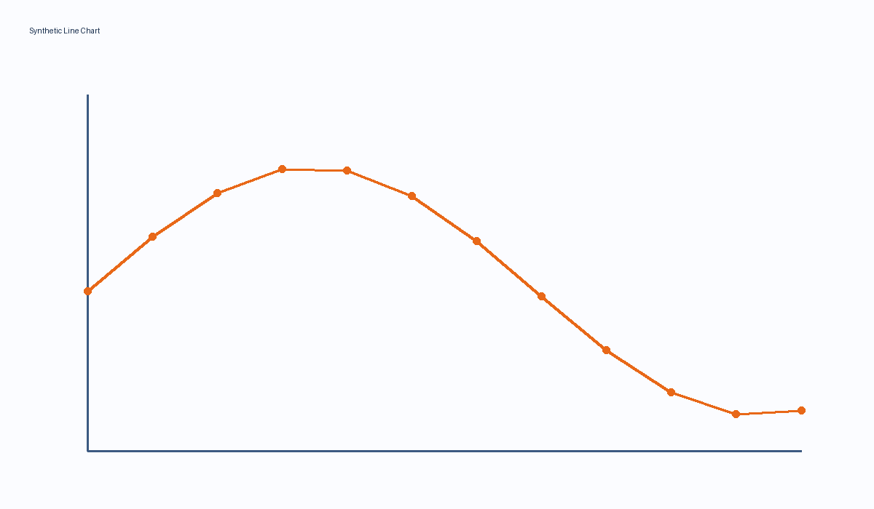
Series | Jan | Feb | Mar
North | 27 | 73 | 41
South | 32 | -13 | -14
Central | 92 | 67 | 70

